**EVERYTHING YOU NEED TO KNOW ABOUT BRACES**

* Braces are a traditional means of treating malaligned teeth and have been used over centuries. Once every decade technology takes a leap and unlike olden times, the newer braces are much more comfortable, faster and less visible.
* TYPES OF BRACES
* DIFFERENCE BETWEEN TYPES OF BRACES
  + Traditional braces (Image 1) are the oldest form of braces and the most widely used variety.
  + They are of 2 types: Metal braces (slightly more visible, more sturdy), Ceramic braces (Slightly less visible, preferred by girls and older teens).
  + Traditional braces are ligated (attached) to the main u-shaped wire by means of an elastic called module. The modules are changed at every visit, but it has been observed in patients treated over many years that:
    - Modules get discolored by food stains (image 2)
    - Food collects more around modules
    - The tightening process done at every visit results in slight soreness for next 2-3 days
    - Extractions are necessary in most cases
    - Tightening is compulsory every month
  + Self-Ligating or Automatic Braces (image 3) also come in a Metal and Ceramic variety.
  + Self-ligating braces do not need modules for tightening. They have a built-in clasp which tightens over the main wire itself, not needed external tightening. This gives the system and edge over the traditional braces:
    - No modules, no discoloration
    - Smaller in size, less visible, less food build up
    - No tightening needed, no soreness after every visit
    - Extractions can be avoided in most cases
    - Self activated, tightening not compulsory every month
    - Ideal for busy students, more comfortable with less visits
* WHAT IS THE BEST TIME TO GET BRACES
  + The ideal time to get braces is after all the milk teeth of the child have been replaced by permanent teeth, although this age can vary in children due to different eating habits.
  + This age coincides with puberty in children; any changes made to the teeth are readily accepted by the body.
  + Owing to newer advancements in the field of dentistry especially digital scanning procedures, there is no upper age limit of braces treatment. Adults of all age can undergo this treatment.
* WHAT ARE RETAINERS AND WHO NEEDS THEM
  + After the treatment is over, the teeth breathe freely after months and immediately try to go back to their original position. To remind them of their new position, they are restrained or held in place by a device called retainers which prevents them from going back to their original position.
  + Retainers can be removable (for children), invisible (for teens) or fixed at the back surface (for adults) (image 4).
  + They need to be worn for 6-12 months depending on the original condition of teeth.
* WHAT DO I EAT OR DRINK AFTER GETTING BRACES
  + We understand that in growing years, it’s difficult to put eating restrictions on children or teens, let’s face it, we love pizza too!
  + There are simple food restrictions with braces, which if followed can allow you to eat all your favorite foods with ease.
  + The rule is never to eat from the front teeth, always break or cut food into small pieces and eat from the back teeth, the chewing continues but the biting stops.
  + Avoid extremely hard or sticky things, especially raw apple or guava, popcorn, walnuts, five star, éclairs etc.
  + If you are innovative and careful you can eat almost anything. If craving pizza, avoid the crust and eat the middle with fork and knife. If craving ice cream, avoid the cone ones and choose the cup ones. If craving chocolate, avoid the fruit and nut ones; choose a plain one, slightly microwaved.

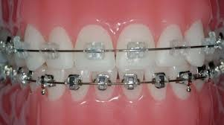 image 1

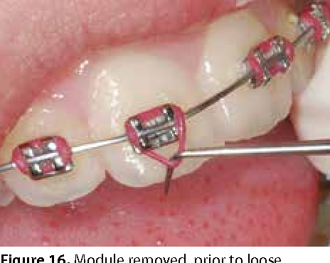 image 2

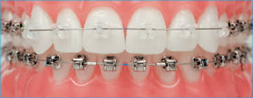 image 3

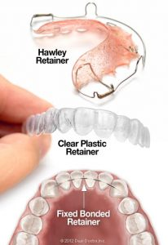 image 4